

Patient information Update

Date:__________________

Name:__________________________ Social Security #__________________Home Phone: ( )____________
Change of Address:___________________________City:___________________State:______ Zip:____________
E-mail address:____________________________Fax # __________________ Cell Phone:__________________

Age:_______ Birth Date:___________ Race:______ Marital: M S W D How many children?____________
Occupation:_________________________ Employer:________________________________________________
Employer's Address:__________________________________ Office Phone:_____________________________ Spouse:___________________ Occupation:________________ Employer:_______________________________
Name of Nearest Relative Not Living With You :______________________________________________________
Address:____________________________________________________________Phone: ( ) _____________

Family Medical Doctor:________________________________________ City _______________
When doctors work together it benefits you. May we have your permission to update your medical doctor regarding your care at this office? YES NO
HISTORY OF PRESENT ILLNESS:
Chief Complaint: Purpose of this appointment:_______________________________________________
Date symptoms appeared or accident happened:_________________________________________
How frequent is the condition? Constant _____ Daily ____ Intermittent ____ Night Only ____
Is there anything you can do to relieve the problem? Yes ___ No ___. If yes, describe _______
___________________________________________________________________________________.
If no, what have you tried to do that has not helped? _________________________________________
What makes the problem worse? Standing ____ Sitting ______ Lying ______ Bending _____
Lifting _____ Twisting _____ Other ________________________________________________
Is this due to: Auto___ Work____ Other________________________________________________
Have you ever had the same or a similar condition? YES NO If yes, when and describe:____________________________________________________________________________________
Other Doctors seen for this condition ____________________________________________________
Days lost from work:_______________ Date of last physical examination:_______________________
Insurance Information

Please circle any and all insurance coverage that may be applicable in this case:

Major Medical Worker's Compensation Medicare Auto Accident
Medical Savings Account & Flex Plans Other
Name of Primary Insurance Company:___________________________________________________________
Name of Secondary Insurance Company (if any):___________________________________________________
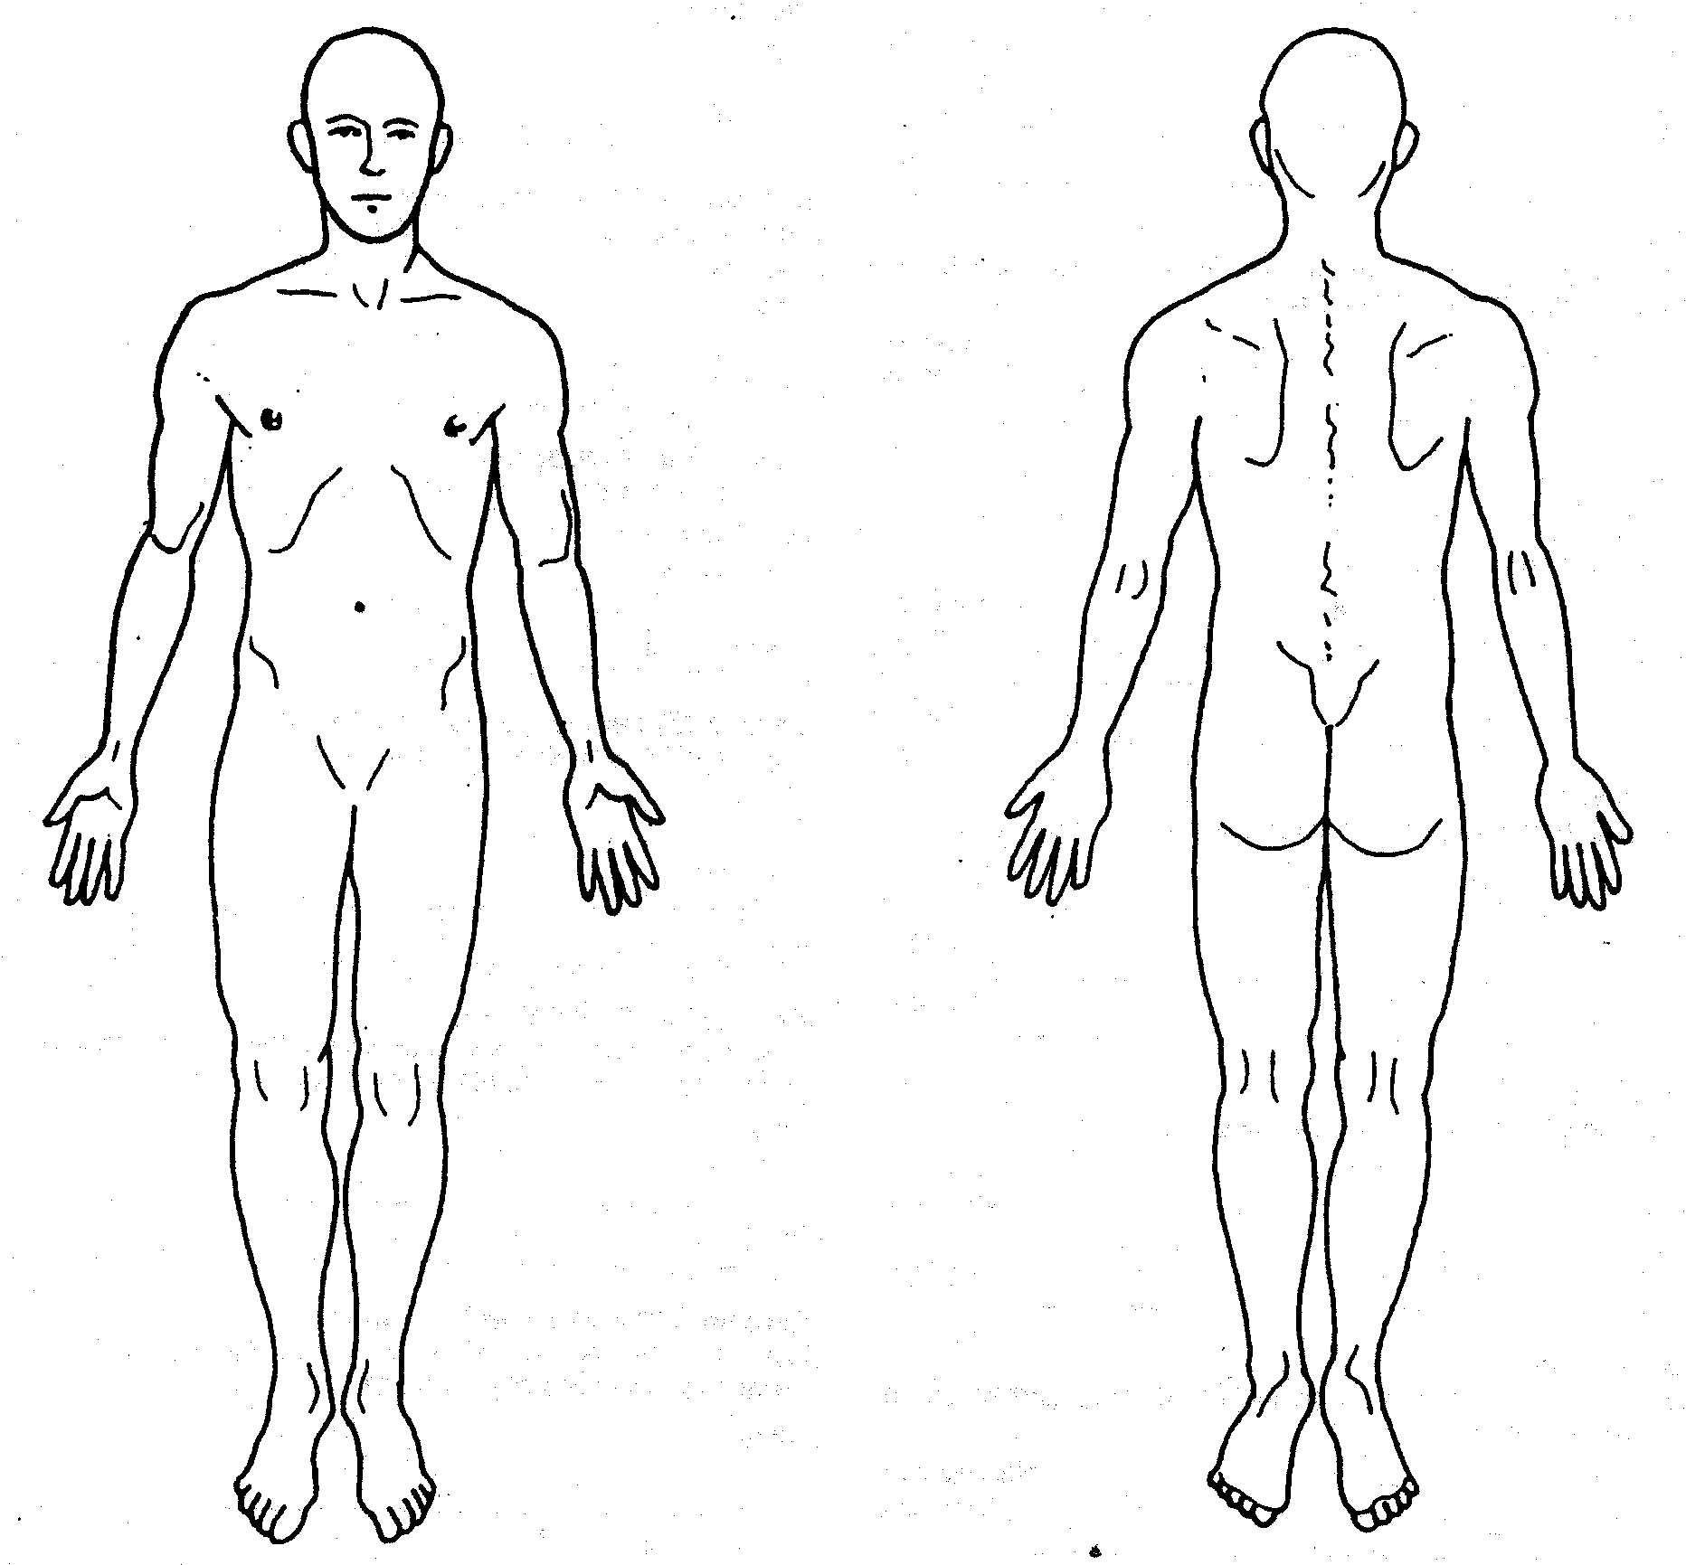
Please check any that you are currently experiencing
Have you had or do you now have any of the following symptoms that are or have been of significant distress to you? Please indicate with the letter N if you have these conditions now or P if you have had these conditions previously.

Broken or fractured bones _____ Rheumatoid Arthritis ______
Osteoarthritis _____ Seizures/ Convulsions ______
Circulatory Problems _____ Strokes ______
A Congenital Disease _____ Cancer ______
Depression _____ Epilepsy ______
Ulcers _____ Pace Maker ______
Alcoholism _____ HIV Positive ______
Drug Addiction _____ Gall Bladder ______
Eating Disorders _____ Ruptures ______
Coughing Blood _____ Excessive Bleeding ______
Headaches_____ Frequency _____ Loss of Balance ______
Neck Pain _____ Fainting ______
Stiff Neck _____ Loss of Smell ______
Sleeping Problems _____ Loss of Taste ______
Back Pain _____ Unusual Bowel Patterns ______
Nervousness _____ Feet Cold ______
Tension _____ Hands Cold ______
Irritability _____ Arthritis ______
Chest Pains/Tightness _____ Muscle Spasms ______
Dizziness _____ Frequent Colds ______
Shoulder/Neck/Arm Pain _____ Fever ______
Numbness in Fingers _____ Sinus Problems ______
Numbness in Toes _____ Diabetes ______
High/low Blood Pressure _____ Indigestion Problems ______
Difficulty Urinating _____ Joint Pain/Swelling ______
Weakness in Extremities _____ Menstrual Difficulties ______
Breathing Problems _____ Weight Loss/Gain ______
Fatigue _____ Depression ______
Lights Bother Eyes _____ Loss of Memory ______
Ears Ring _____ Buzzing in Ears ______

On the diagram mark the areas on your body where you feel your pain. Include all affected areas. Mark areas of radiation. If your pain radiates, draw an arrow from where it starts to where it stops. Please extend the arrow as far as the pain travels. Use the appropriate symbol (s) listed below.

Ache ***** Numbness +++++
Pins & Needles ooooo
Burning xxxxx Stabbing <<<<<< Throbbing /////////

What medications or drugs are you taking?_________________________________________________________

What vitamins/supplements are you taking?_________________________________________________________

___________________________________________________________________________________________
AUTHORIZATION AND RELEASE: I authorize payment of insurance benefits directly to the chiropractor or chiropractic office. I authorize the doctor to release all information necessary to communicate with personal physicians and other healthcare providers and payors and to secure the payment of benefits. I understand that I am responsible for all costs of chiropractic care, regardless of insurance coverage. I also understand that if I suspend or terminate my schedule of care as determined by my treating doctor, any fees for professional services will be immediately due and payable.

The patient understands and agrees to allow this chiropractic office to use their Patient Health Information for the purpose of treatment, payment, healthcare operations, and coordination of care. We want you to know how your Patient Health Information is going to be used in this office and your rights concerning those records. If you would like to have a more detailed account of our policies and procedures concerning the privacy of your Patient Health Information we encourage you to read the HIPAA NOTICE that is available to you at the front desk before signing this consent. If there is anyone you do not want to receive your medical records, please inform our office.

Patient's Signature:_____________________________________________________ Date:________________
Guardian's Signature Authorizing Care:_____________________________________ Date:________________

